**The Spontaneous Refuge and Bodhichitta Practice that Tames the Windhorse Through Natural Splendor**

**by Ngakchang Karma Yeshe Namgyal Dorje Rinpoche**

All sentient beings have been our mother and father countless times. Our friends have been our enemies and our enemies will become our friends. All sentient beings are Buddhas and compassion is aimless in nature, so equanimity is the ground from which Bodhicitta manifests. Therefore, equanimous perception of phenomena is the Buddha's view. This is the fourth, but (in reality) the primary, immeasurable wish.

When we recognize this phenomenal display as our teacher helping us examine our own motivations so we may remove our obscurations through mindfulness and vigilance, we realize the secret great kindness of all beings who manifest in our display world; and our Lama's kindness, a kindness manifesting through countless Kalpas, which embodies the patience of the uncreate, waiting eons for us to tame one thought/feeling. This realization creates the wish to return their loving kindness, like a spontaneous blooming of countless lotuses, with innumerable wisdom beings as their sun and moon pollen beds, bursting from our heart chakra pervading all samsara and nirvana. The happiness of constant giving/receiving of loving kindness is the first immeasurable wish. In order to accomplish it, we use the sublime method of all the Buddhas and Bodhisattvas, the Eightfold Noble Path, and receive refuge in the fact of Buddha Mind, the Teachings, and the Sangha, the community of practitioners and recite the four immeasurable wishes. Acknowledging that all sentient beings are Future Buddhas, to potentiate the propensities of all sentient beings towards enlightenment, we include them in our visualization.

**Outer, Inner, and Secret Refuge Practice of the Mahasiddha Thangtong Gyalpo**

མ་ནམ་མཁའ་དང་མཉམ་པའི་སེམས་ཅན་ཐམས་ཅད་བླ་མ་སངས་རྒྱས་རིན་པོ་ཆེ་ལ་སྐྱབས་སུ་མཆིའོ། །

**ma namkha dang nyampé semchen tamché lama sangye rinpoche la kyab su chi o**

All mother sentient beings as infinite as space receive refuge in the guru, the precious Buddha.

སངས་རྒྱས་ཆོས་དང་དགེ་འདུན་རྣམས་ལ་སྐྱབས་སུ་མཆིའོ། །

**sangye chö dang gendün nam la kyab su chi o**

In the Buddha, Dharma and Saṅgha, we receive refuge.

བླ་མ་ཡི་དམ་མཁའ་འགྲོའི་ཚོགས་ལ་སྐྱབས་སུ་མཆིའོ། །

**lama yidam khandrö tsok la kyab su chi o**

In the assembly of gurus, yidam deities and ḍākinīs, we receive refuge.

རང་སེམས་སྟོང་གསལ་ཆོས་ཀྱི་སྐུ་ལ་སྐྱབས་སུ་མཆིའོ། །

**rangsem tongsal chö kyi ku la kyab su chi o**

In the dharmakāya, the inseparable emptiness and clarity of our own minds, we receive refuge.

May all sentient beings have happiness and its cause.

May all sentient beings be free from suffering and its cause.

May all sentient beings have the bliss free from suffering.

May all sentient beings rest in equanimity, free of attachment, aversion and ignorance.

All of our parent beings, who have been so kind to us, are suffering in samsara. Deluded by primordial ignorance (avidya/marigpa), they do not understand why they are suffering - they long for happiness yet continue to suffer! They have no or little comprehension of the dualistic method of perceiving reality and the consequences of the influence of this view create many negative actions of the three gates of body, speech, and mind. Therefore, they continue to create more suffering with no view/method to release them from the endless wheel of birth and death - the vicious cycle of samsara. We vow to liberate them from their suffering! This is second immeasurable wish.

*Effortlessly, from our lotus hearts, countless golden pollen grains manifest, each becoming a lotus sun and moon upon which sits the Lord of Compassion, Chenrezig, radiating rays of light (from the lotus and six syllables in his heart) that fill the vast unobstructed opening space with nectarine compassion.*

We are humbled and grateful to have the wondrous good fortune of a precious human birth, a healthy body with all our senses intact; the love and protection of kind parents or care givers; to meet the holy Dharma in a fortunate kalpa (where a Buddha incarnates); and to have the leisure time to practice the jewel of Dharma in a country that was founded on the freedom to practice one's spiritual path. Aspirational Bodhicitta is generating the wish that all sentient beings attain the same marks of good fortune above, and experience the fruits of the four immeasurable wishes, becoming fully liberated from the sufferings of cyclic existence (samsara).

*Om gate gate paragate parasamgate bodhi swaha*

*We vow to lead all sentient beings through the endless samsaric seas, to the shore of Enlightenment!*

*The ship of Dharma is captained by equanimity and the steward of loving kindness continuously benefits sentient beings!*

*Our navigator is the Lord of Compassion, Chenrezig!*

*The holy sublime Sangha sing the never ending Dohas (spiritual songs) of realization, inspiring us to constantly apply ourselves to the liberation of all sentient beings through the Six Paramitas of the Bodhisattva Path!*

1. **Generosity:** The giving of the Dharma, the protection of refuge and mundane sheltering, the saving of lives and material charity.
2. **Morality:** The motivation to always benefit sentient beings through the accumulation of virtuous activity and to abstain from non-virtuous activity.
3. **Patience:** The practice of patience in our daily lives, while meditating, and when receiving teachings.
4. **Diligence:** The belief, courage, and volition that we can accomplish the state of Buddhahood for our self and all sentient beings; motivating us now, in the present moment, to practice strongly, for our time of death is unknown.
5. **Meditation:** This is the daily, and ultimately every moment, process by which the three poisons of ignorance, desire, and aversion are transformed into the experiential modalities of vast unobstructed opening space inseparable from its dynamic of luminosity, bliss, and clarity. These transform into Dharmakaya, Sambhogakaya, and Nirmanakaya. This meditative openness (samadhi), may be categorized in three stages: The first is like a small child's fascination and wonderment with his experiential reality. In the second stage, attachment to the experience of wonderment vanishes, but there still remains a subtle attachment to the vast unobstructed opening space. During the third stage, even the subtle attachment of the vast unobstructed opening space is cut and the meditator rests naturally in the intrinsic, profound, non-conceptual primordial awareness (rigpa). The phenomenal display has both arising and cessation, but realization is unchanging like clouds appearing and disappearing in the vast opening emptiness of the sky. The Three Kayas are recognized in their primordial inseparability. Thus, the Lord Buddha made paramount the yogic experience of meditative absorption.
6. **Wisdom** may be divided into three categories: The first is education - gathering the knowledge of samsara and Nirvana. Samsaric knowledge concerns itself with the mundane sciences; knowledge related to the attaining of nirvana includes all Dharma teachings - the Vinaya, Abidharma Sutras (Theravada and Mahayana), Tantras, and commentaries. We, as students, should listen attentively to our Lama's teachings, contemplate them, and practice them with faith and diligence. Our view, grounded in experience, must be continually clarified until all doubt is eliminated. The second category of wisdom is accomplished by the process of contemplation based on a faith born of stainless reasoning that penetrates deeply into the purity of the Buddha's teachings, until one's realization ripens and not one iota of doubt in regards to the view, meditation, and action remains. Wisdom of meditation is the third and most important category, enabling us to realize the view based on stainless reasoning and to test that view in the context of yogic experience. This is not a complex intellectual exercise. It is a simple, clear view coupled with the yogic experience. Since this is done without any intellectualizing, one can become totally free of doubt.

To summarize, the first five of the six paramitas are considered skillful means (upaya). The sixth paramita, wisdom (jnana), is the perfect realization of primordial awareness i.e. the Buddha Mind. The six paramitas are expressed in one's daily life and then become the living validation of the Buddha's teaching. Thus, the application of six paramitas (perfections) becomes the modality of our realization and allows a faith born of stainless reasoning to penetrate deeply from the purity of the Buddha's teachings until one's realization ripens and no trace of doubt remains in regards to the view, meditation, and action.

When the Lord Buddha experientially realized the interdependency of all beings, the aimless compassion of the Bodhisattva arose and pervaded the three times and ten directions. The Buddha then wandered through India as a humble monk with a begging bowl, turning the wheel of Dharma for the sake of all sentient beings for over 50 years until his paranirvana (leaving his earthly body). The Lord Buddha demonstrated through his virya (ceaseless energy directed toward benefiting sentient beings) that he was the embodiment of relative and absolute Bodhicitta, the inseparability of the vast, unobstructed, opening space and luminous/clarity/bliss as the dynamic play of aimless compassion. Since the Lord Buddha's view of dependent origination precludes taking refuge for oneself as an isolated monad, aimless compassion manifests spontaneously as an intrinsic component of Enlightened Mind's luminous clarity and radiating bliss, inseparable from the vast unobstructed opening space (absolute Bodhicitta). Bodhichitta has two aspects, aspirational/applied and ultimate.

Applied Bodhichitta is acting according to the first five Paramitas while engaging with interdependent phenomena from the view of absolute Bodhichitta (the Sixth Paramita), so all phenomena may co-originate in a way that accomplishes this sublime aspiration, the intent of all Buddhas and Bodhisattvas. Aspirational Bodhichitta is generating the wish to attain this compassionate wisdom power. We take the Lord Buddha Shakyamuni as our paragon example and not only intend to accomplish the entire lineage aspiration of the Noble Ones but courageously drop everything to let blaze the torch of Buddha Dharma: to become a beacon of pure bodhicitta, wisdom, and loving kindness for the enlightenment of all sentient beings.

*Now, the radiant luminosity molecules (that form each of the golden grains uniting to form the amrita pollen beds of Chenrezig in our heart of hearts pervading all of space) pour forth a cornucopia of indescribable bliss/joy nectar. The nectar flows forth, melting and blazing so awesomely that a transfiguration of our winds, channels, chakras, and vital essence occurs. This is the Mahasukha, the Great Bliss. We naturally wish that all our parent sentient beings realize this supreme joy (the third wish) and that through attaining happiness, freedom from suffering, great bliss, they may discover natural equanimity within their own mindstreams, which have been inseparable from Buddha Mind all along.*

*As this blissful wisdom nectar flows into all beings, we recite as much as possible:*

*The Six Syllable Mantra of Great Compassion*

*that Closes the Doors to the Six Realms of Samsara:*

**OM MA NI PAD ME HUM**

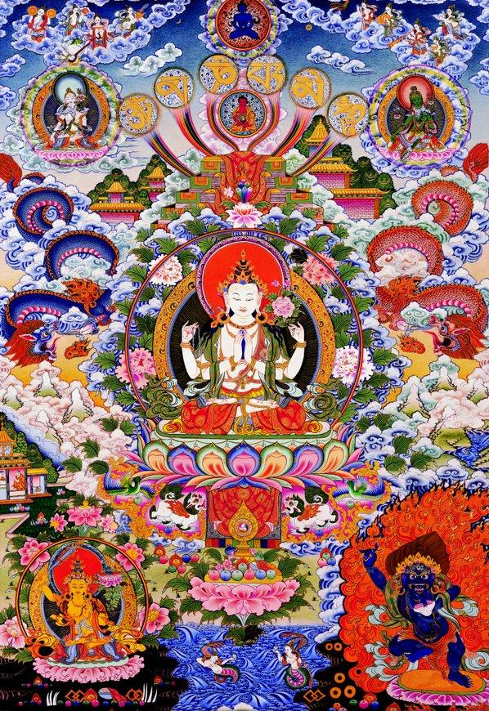

*Chenrezig’s radiant essence dissolves into the hearts of all my mothers and myself.*

Refuge in conjunction with the development of Bodhicitta, the mind of great awakening, brings us into the Bodhisattva Marga, the path of the Bodhisattva - the Mahayana, the great vehicle. We receive refuge and accomplish our liberation for the sake of all sentient beings, vowing to ceaselessly work for their benefit until each and every one of them has attained total liberation. This Bodhisattva vow, perhaps the most sublime creation of the human mind, is based on the Buddha’s view of the interdependent origination of all phenomena (dharmas). The dualistic separation created by primordial ignorance perceives a divided “reality”, when in reality there never was, is, or will be separate monads or entities fated to an eternal isolation and suffering.

*Having generated the Mind of Enlightenment in this way, the Dakinis (female Wisdom Beings), Dakas (male Wisdom Beings), and Dharmapalas (Dharma protectors) rejoice and energize and protect the practitioner on the path.*

*By this merit*

*May all attain omniscience*

*May it defeat the enemy, wrongdoing*

*From the stormy waves of birth, old age, sickness, and death*

*From the ocean of samsara*

*May I free all beings!*

*SARVA MANGALAM!*

*Colophon: Compiled from the text Lungta Zilgnon (Taming the Windhorse Through Awesome Splendor) by my Teacher, Ngakchang Karma Yeshe Namgyal Dorje Rinpoche, in Los Angeles on the morning of 11/30/2021 on a whim. The air in Venice is full of auspicious mist. Last night before bed my mother gave me a set of prayer flags and asked me to hang them tomorrow. I woke up with swollen tonsils but after compiling this, my throat has been restored. I don’t know how to compile a practice but I noticed these aspects in the text and wanted to expand them for others. May it be of benefit!*

**